# Sideways Elevator System

Pierre Fandy Francois

Florida SouthWestern State College

CIS 2321: SYSTEMS ANALYSIS AND DESIGN

Dr. Ken Belcher

12/01/2024

# Executive Summary

This document outlines the requirements for designing and implementing an advanced elevator capable of supporting sideways travel. Commissioned by WW Elevators, this proposal upgrades existing systems with innovative features that allow multi-directional navigation, enhancing user experience and operational efficiency. The report covers system requirements, performance benchmarks, design constraints, and schedules.

**System Requirements**

Functional Requirements:  
- The elevator panel should provide directional options (up, down, left, right).  
- Ensure seamless integration with existing elevator systems.  
- Display real-time position and direction on a screen.  
  
Non-Functional Requirements:  
- Ensure compliance with international elevator safety standards.  
- The system must support load balancing for horizontal movement.

**Performance Requirements**

- The elevator must switch between vertical and horizontal travel modes in under 2 seconds.  
- Speed: Maintain a travel rate of 2 meters per second horizontally.  
- Reliability: The system should operate with 99.99% uptime.  
- Response Time: Panel inputs must be processed within 0.5 seconds.

**Design Constraints**

- Physical Constraints: The panel must fit within existing ascensor dimensions.  
- Technical Constraints: Compatibility with existing control systems and infrastructure.  
- Budgetary Constraints: Limited to $2 million for the project.

**Schedule and Budget**

Schedule:  
- Phase 1: Requirements Analysis (2 weeks)  
- Phase 2: System Design (1 month)  
- Phase 3: Implementation (2 months)  
- Phase 4: Testing & Validation (1 month)  
- Phase 5: Deployment (2 weeks)  
  
Budget:

|  |  |
| --- | --- |
| Process | Cost |
| Development: | $800,000 |
| Testing: | $400,000 |
| Installation: | $600,000 |
| Training and Support: | $100,000 |
| Total: | $1,900,000 |

**Appendices**

Diagrams:  
- Current System: 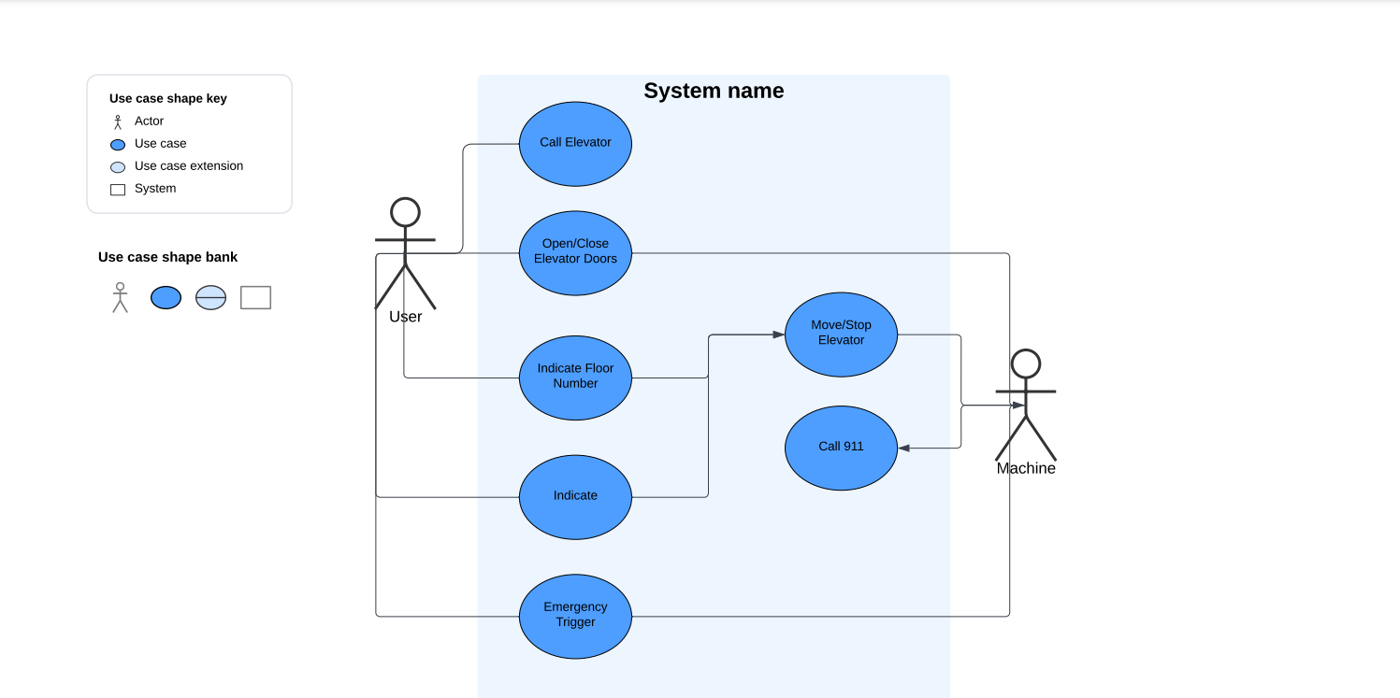  
- Proposed System: 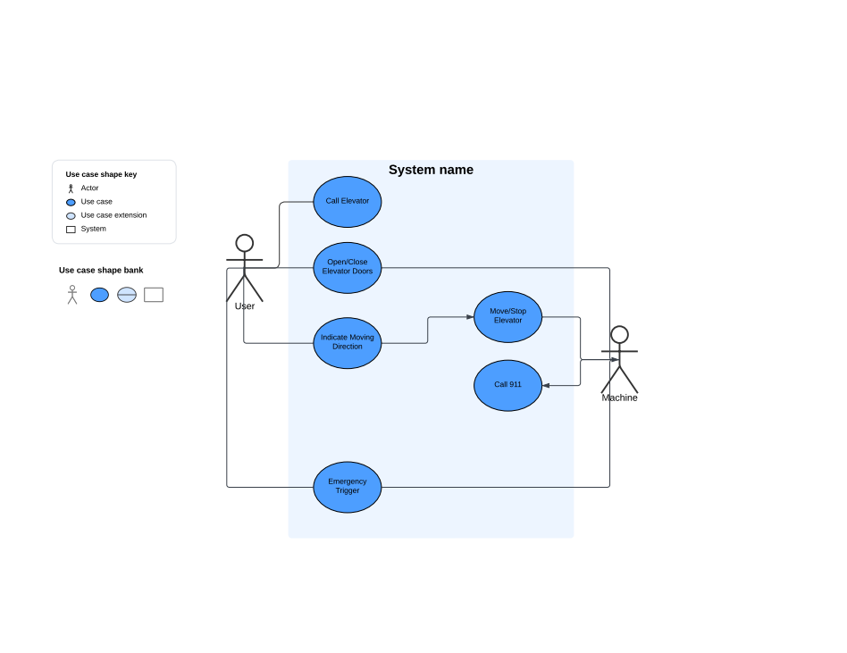

# References

Fischer, J. (2017, June 22). *Press release*. thyssenkrupp. <https://www.thyssenkrupp.com/en/newsroom/press-releases/thyssenkrupp-makes-the-future-a-reality--inauguration-of-the-world-s-first-rope-less-horizontal-vertical-elevator-system--multi-1560.html>